**DB design for Guvi Zen class**

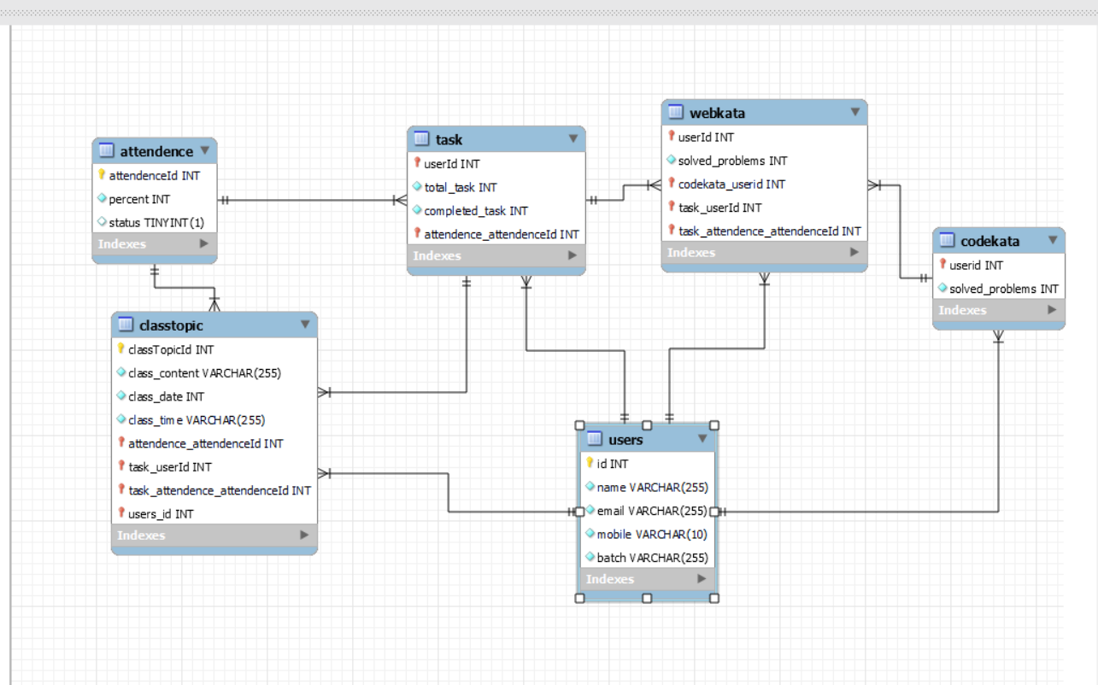

create database zenClass;

use zenClass;

create table users (

id int auto_increment primary key,

name varchar(255) not null,

email varchar(255) unique not null,

mobile varchar (10) not null,

batch varchar(255) not null

);

insert into users (name,email,mobile,batch) values

('manoj', 'manojsundaram@gamil.com', '1234567890', 'B53'),

(' kumar ', 'kumar@gamil.com', '9874563210', 'B52'),

(' mani ', 'mani@gamil.com', '7412589630', 'B51'),

(' kamel ', 'kamel@gamil.com', '3698521470', 'B50'),

(' saravanan ', 'saravanan@gamil.com', '3216549870', 'B49');

select * from users;

create table codekata (

userId int auto_increment primary key,

solved_problems int not null,

foreign key(usersId) references users(id)

);

insert into codekata (userId,solved_problems) values

(1,82),

(2,90),

(3,96),

(4,88),

(5,91);

select * from codekata;

create table webkata (

userId int auto_increment primary key,

solved_problems int not null,

foreign key(userId) references users(id)

);

insert into webkata (userId,solved_problems) values

(1,80),

(2,94),

(3,95),

(4,82),

(5,89);

select * from webkata;

create table task (

taskId int auto_increment primary key,

userId int not null,

total_task int not null,

completed_task int not null,

foreign key(userId) references users(id)

);

insert into task(userId,total_task,completed_task) values

(1,24,19),

(2,24,22),

(3,24,24),

(4,24,23),

(5,24,18);

select * from task;

create table classTopic (

classTopicId int auto_increment primary key,

class_content varchar(255) not null,

class_date varchar(255) not null,

class_time varchar(255) not null

);

insert into classTopic (class_content, class_date, class_time) values

('Html', 12/9/23, '9.00am'),

('javascript', 20/11/23, '9.00am'),

('mysql', 2/12/23, '9.00pm'),

('reactjs', 10/11/23, '9.00am'),

('nodejs', 23/12/23, '9.00pm');

select * from classTopic;

create table attendence (

attendenceId int auto_increment primary key,

percent int not null,

status boolean default true

);

insert into attendence (percent) values

(80),

(84),

(90),

(95),

(75);

select * from attendence;